**Supplementary Materials for**

**Characteristics of air quality in different climatic zones of China during the COVID-19 lockdown**

**This document includes Supplementary text, Supplementary Fig S1 - S8 and Supplementary Table 1.**

**Supplementary text**

Wind speeds of YR, CS, SC, and TP barely changed through all stages (Fig. S1, Fig. S2). In contrast, the wind speeds of NEC, NW, NCP, and MG increased significantly in Level 2 and Level 3 (around 2m/s growth from Pre-lockdown to Level 3). High wind speed can prevent pollutants from accumulating near the ground and help reduce pollutant concentration (Hu, Wang, Ying, & Zhang, 2014).

The temperature growth in YR, SC and CS was smaller than that in NEC, NW, NCP and TP (Fig. S1, Fig. S2). From January 1st to April 18th, the temperature in NEC (the highest latitude region) increased by 30.4°C, with an average temperature of -15.3 °C. The temperature in SC (the lowest latitude region) rose by only 6.3 °C, with an average temperature of 14.0 °C. At low temperature, the inversion layer would hinder the dispersion of pollutants.

Precipitation is conducive to the removal of air pollutants. It is evident in Fig. S1, Fig. S2 that the intensity and frequency of rainfall in YR, CS, and SC were great, which led to a low level of concentration and fluctuation. Besides, high humidity in some regions is conducive to the formation of sulfate and nitrate (Sun et al., 2020).

The diurnal variations of the temperature and wind speed reflect local boundary layer structure and thus influence the dispersion condition (Zhao et al., 2009). It can be seen from Fig. S3 that the wind speeds of NCP, TP, MG, and NW varied significantly in a day: the average of diurnal ranges at each stage was 1 ~ 2 m/s. Meanwhile, the diurnal range was the largest in TP (average diurnal range of 2.6m/s). In comparison, daily variations of wind speed in YR, SC and CS were small: the average daily ranges were below 1m/s. The diurnal ranges of wind speed increased with time, especially evident in NEC, NW, MG, and TP. The high wind speed would improve the boundary layer diffusion conditions and weaken the diurnal peak. As for the temperature, the diurnal temperature ranges in NEC, NW, MG and NCP were about 10-11℃. The diurnal temperature range in TP was the largest (12.2°C). In comparison, it was around 6.5 °C in YR, CS, SC.

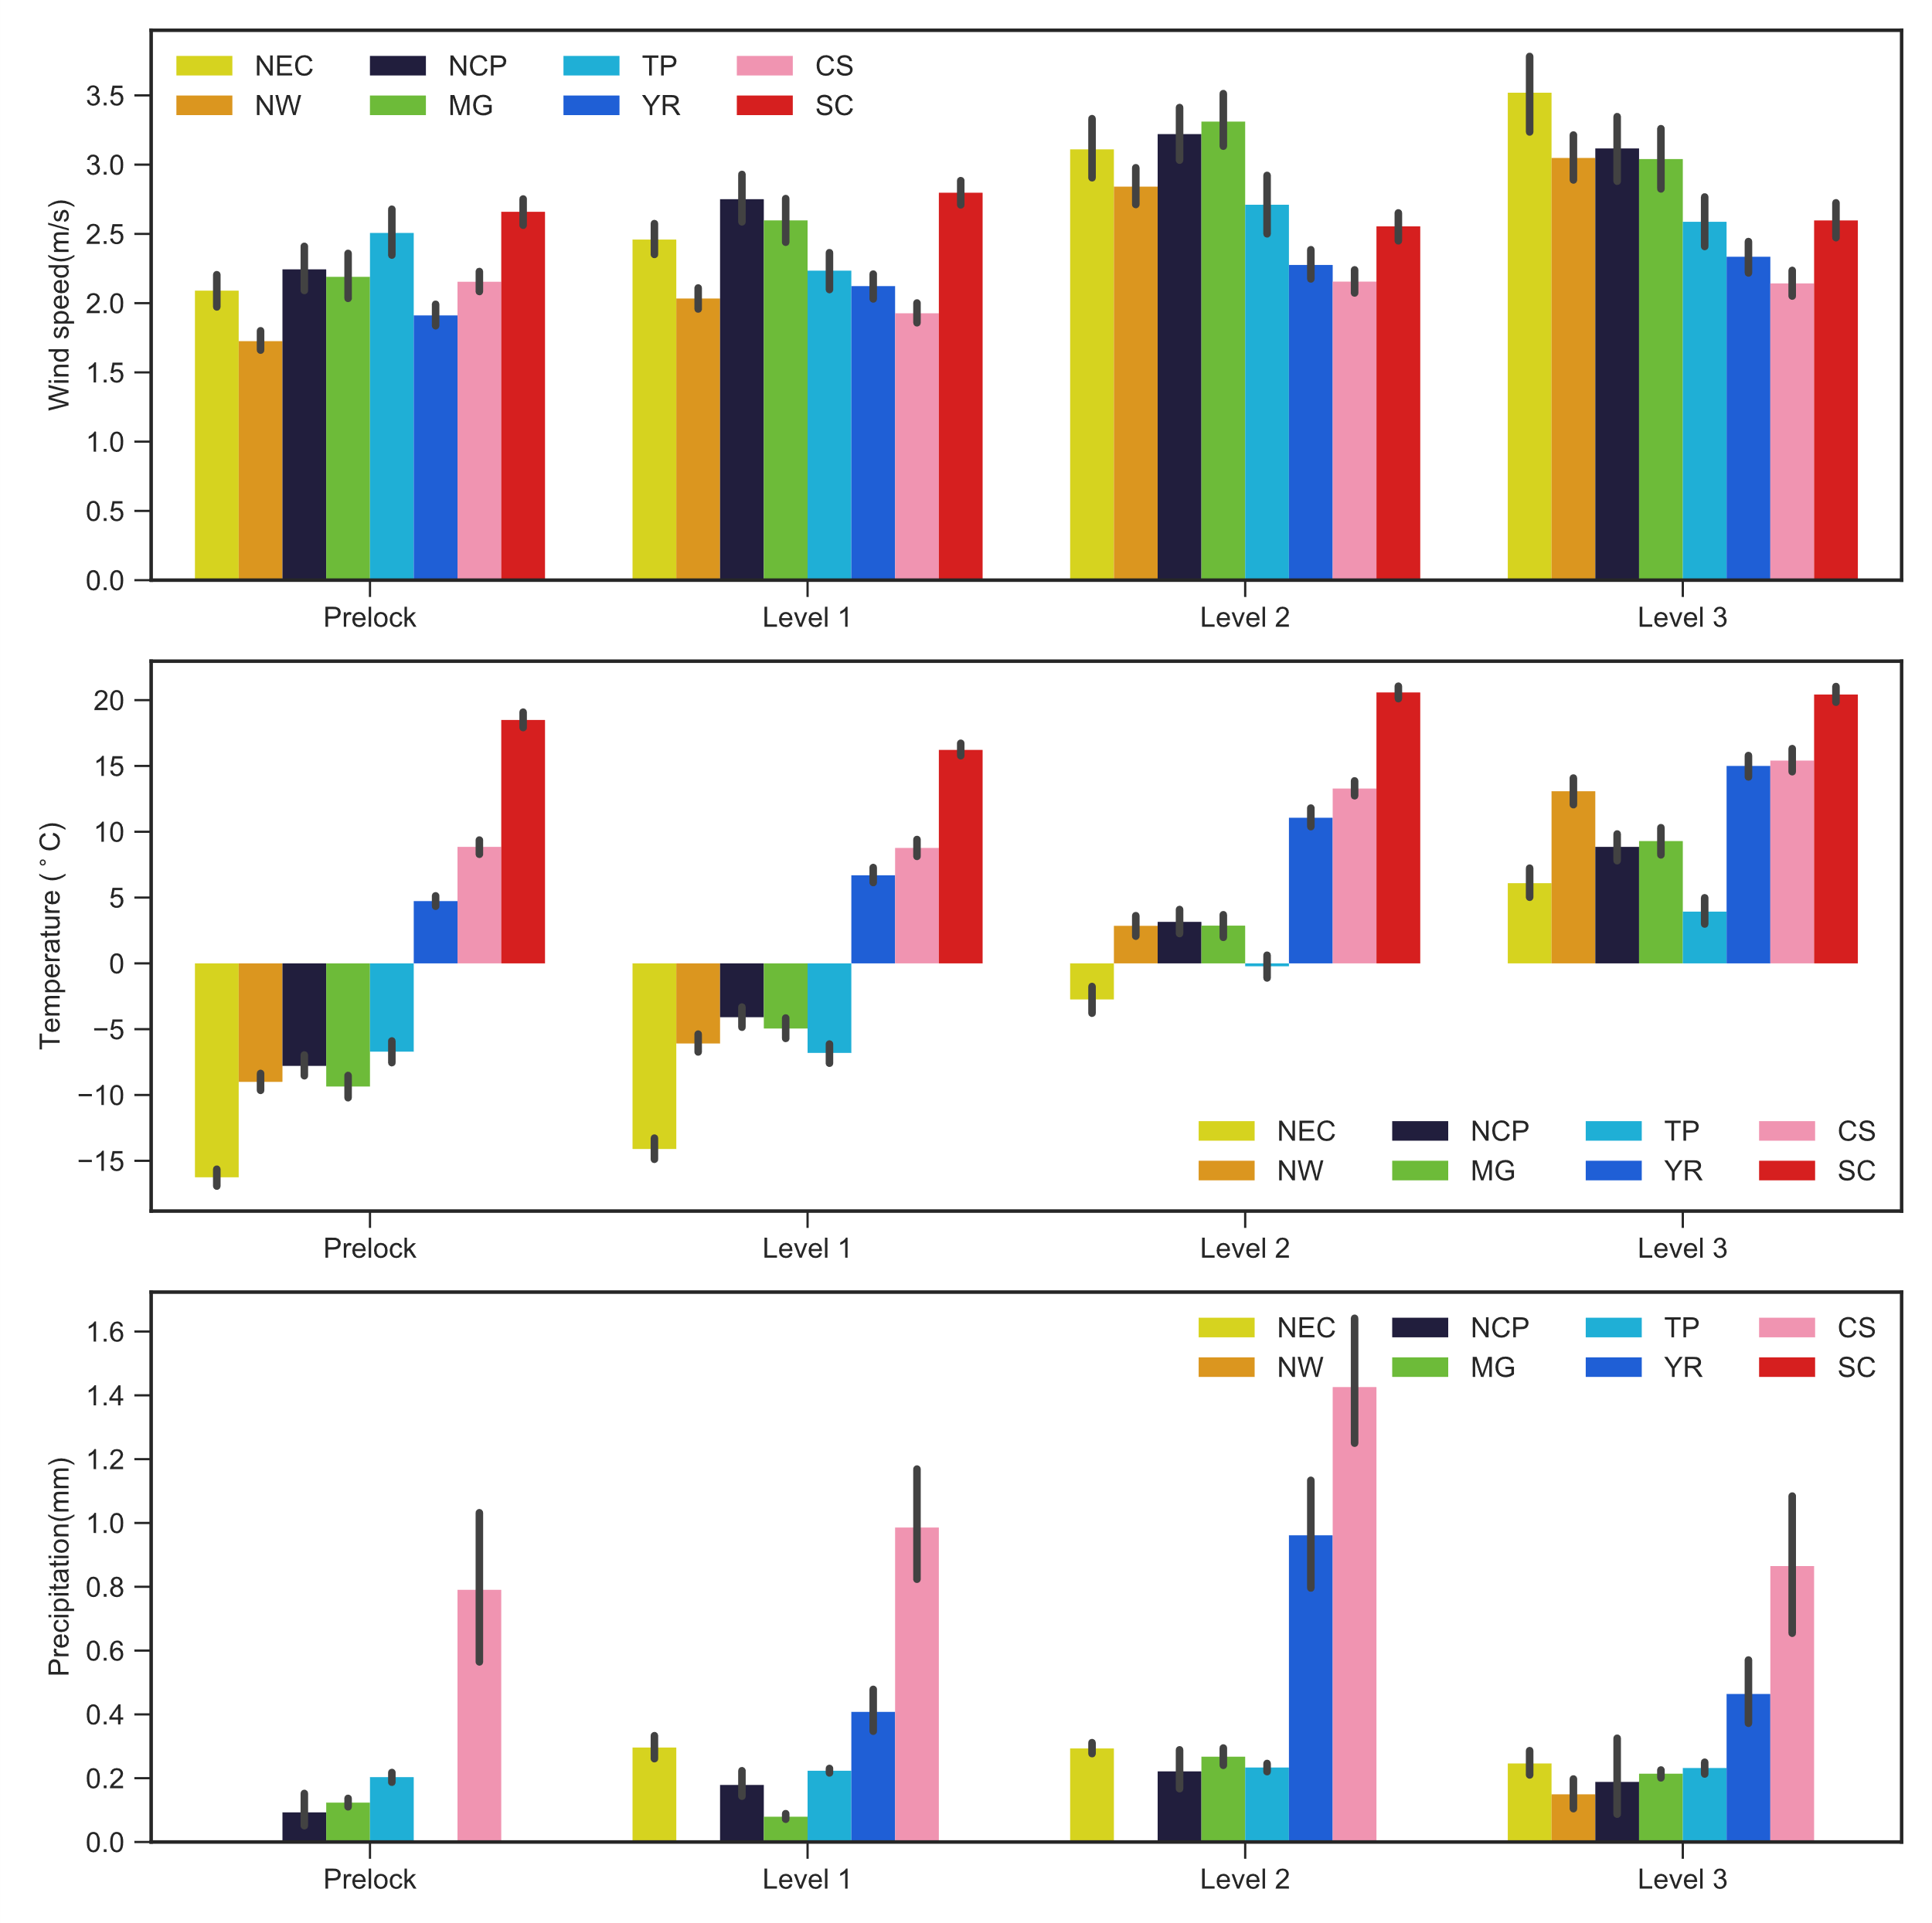

**Fig. S1.** Daily averages of wind speed, temperature and precipitation for Prelock, Level 1, Level 2 and Level 3

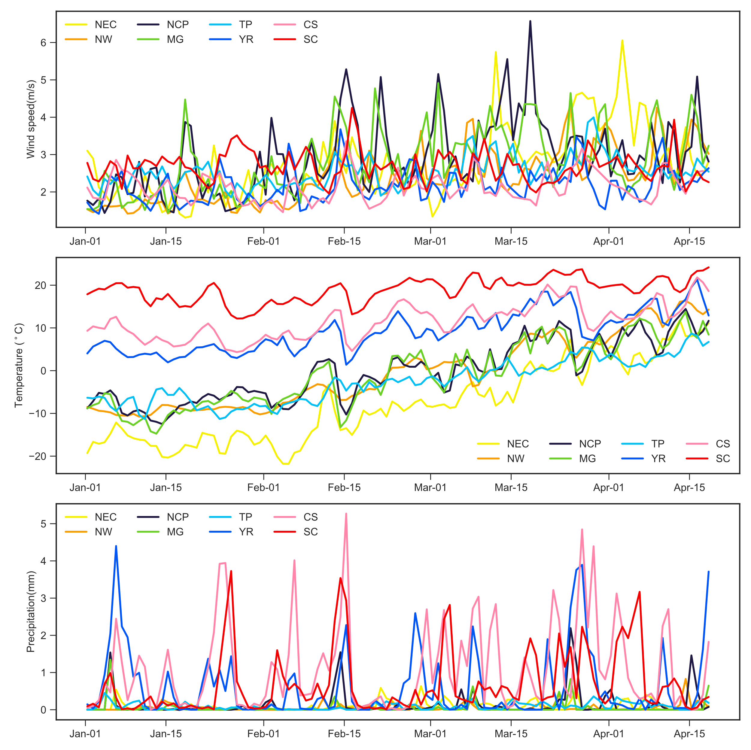

**Fig. S2.** Time series of wind speed, temperature and precipitation from January 1st to April 18th

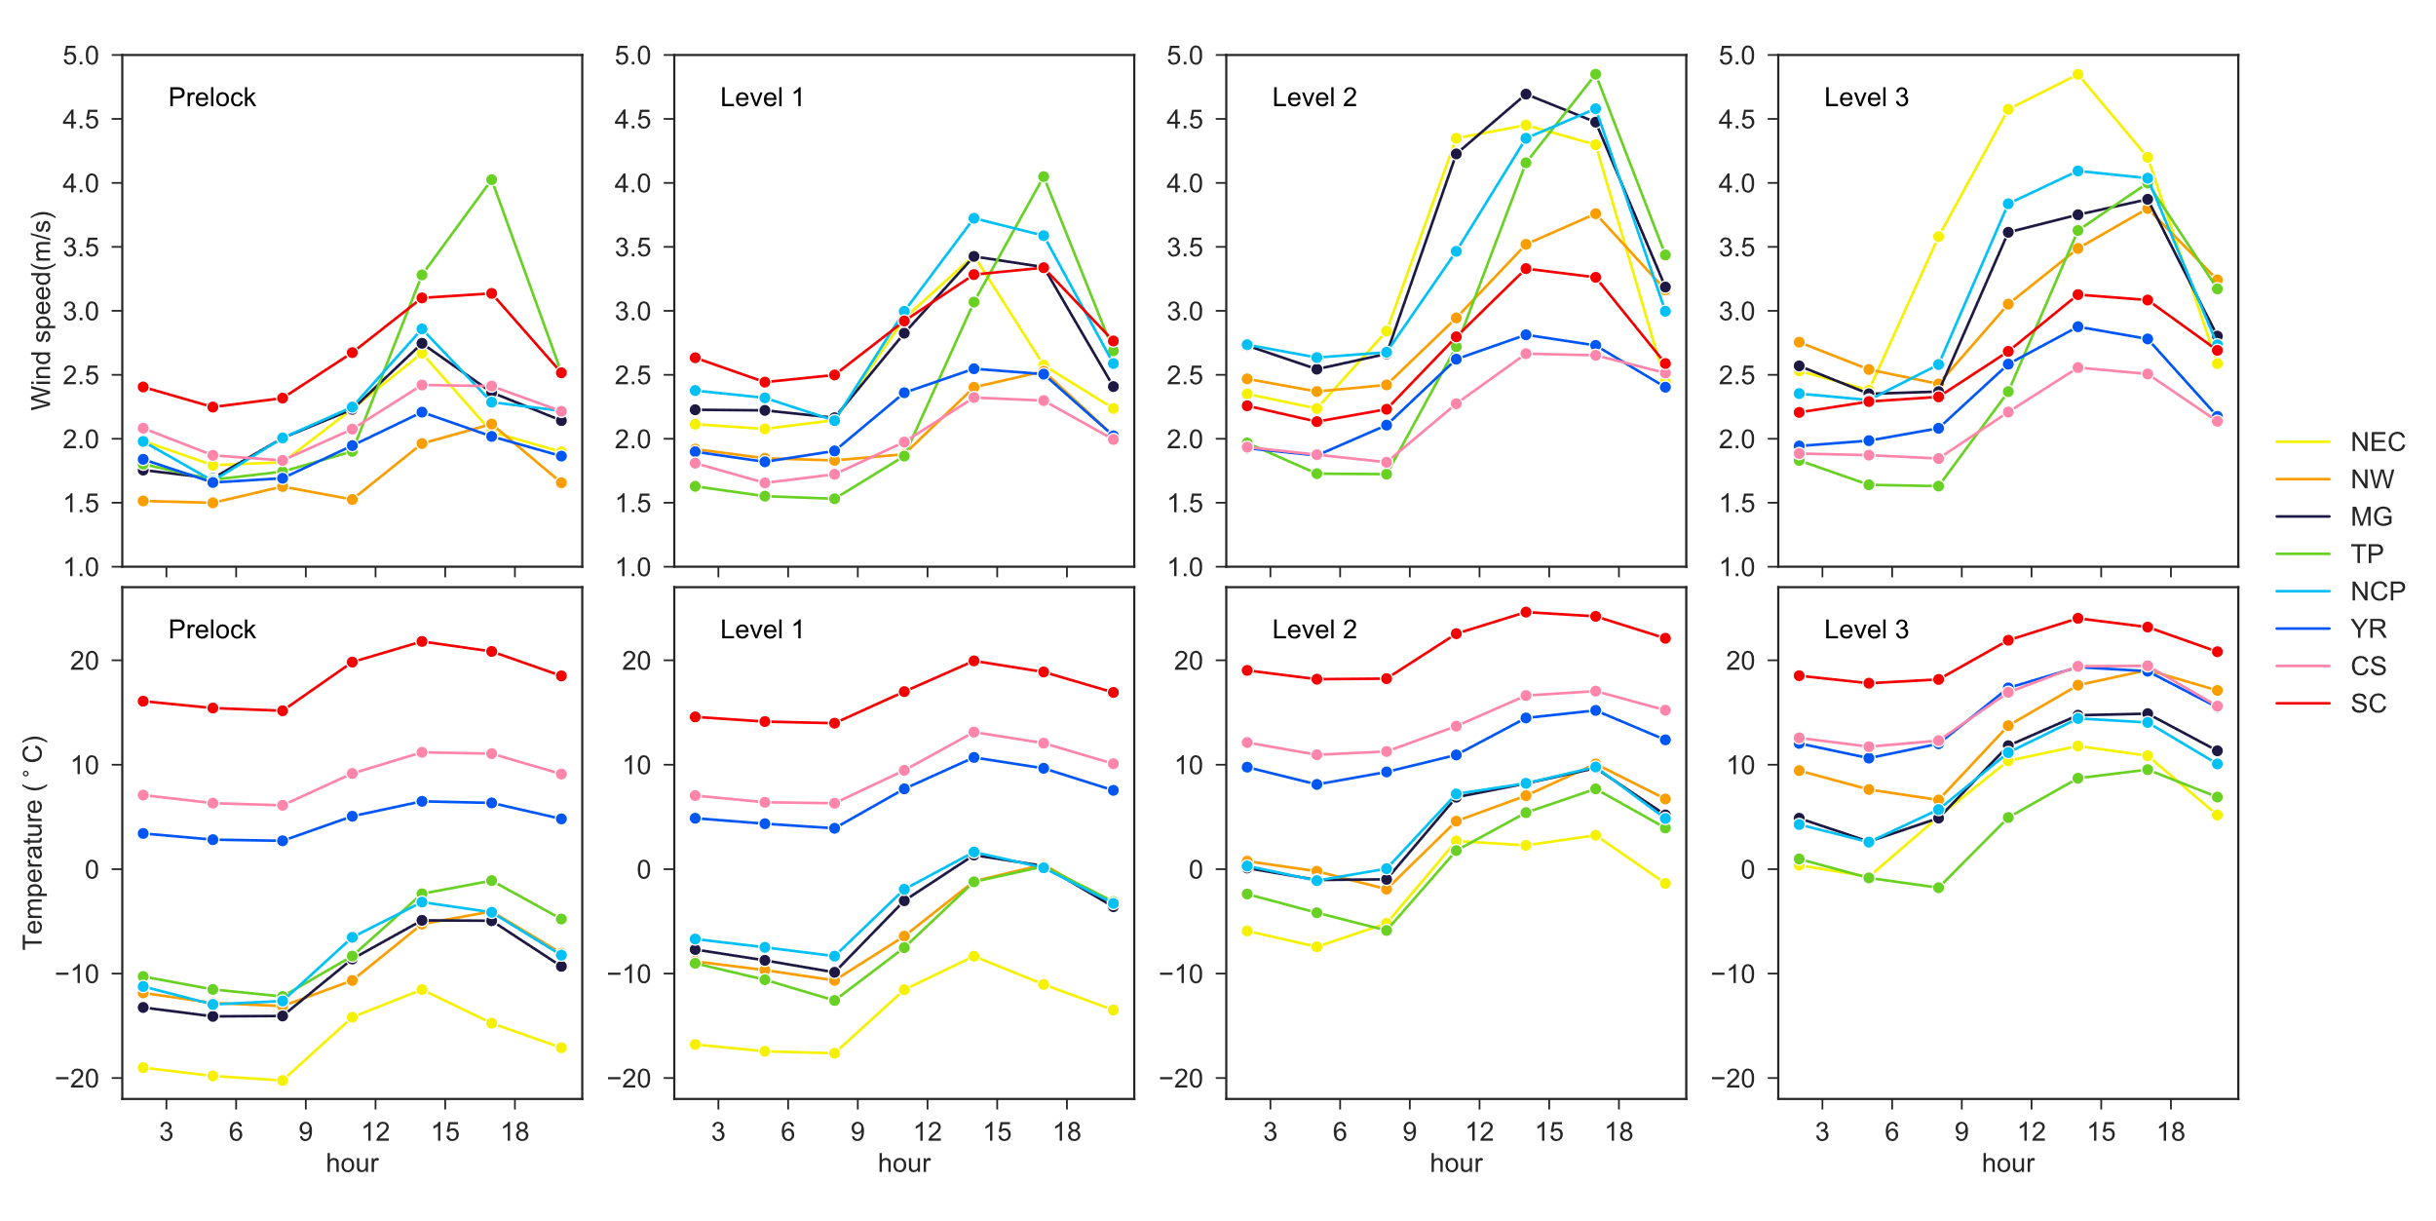

**Fig. S3.** Diurnal variations of wind speed and temperature in four stages

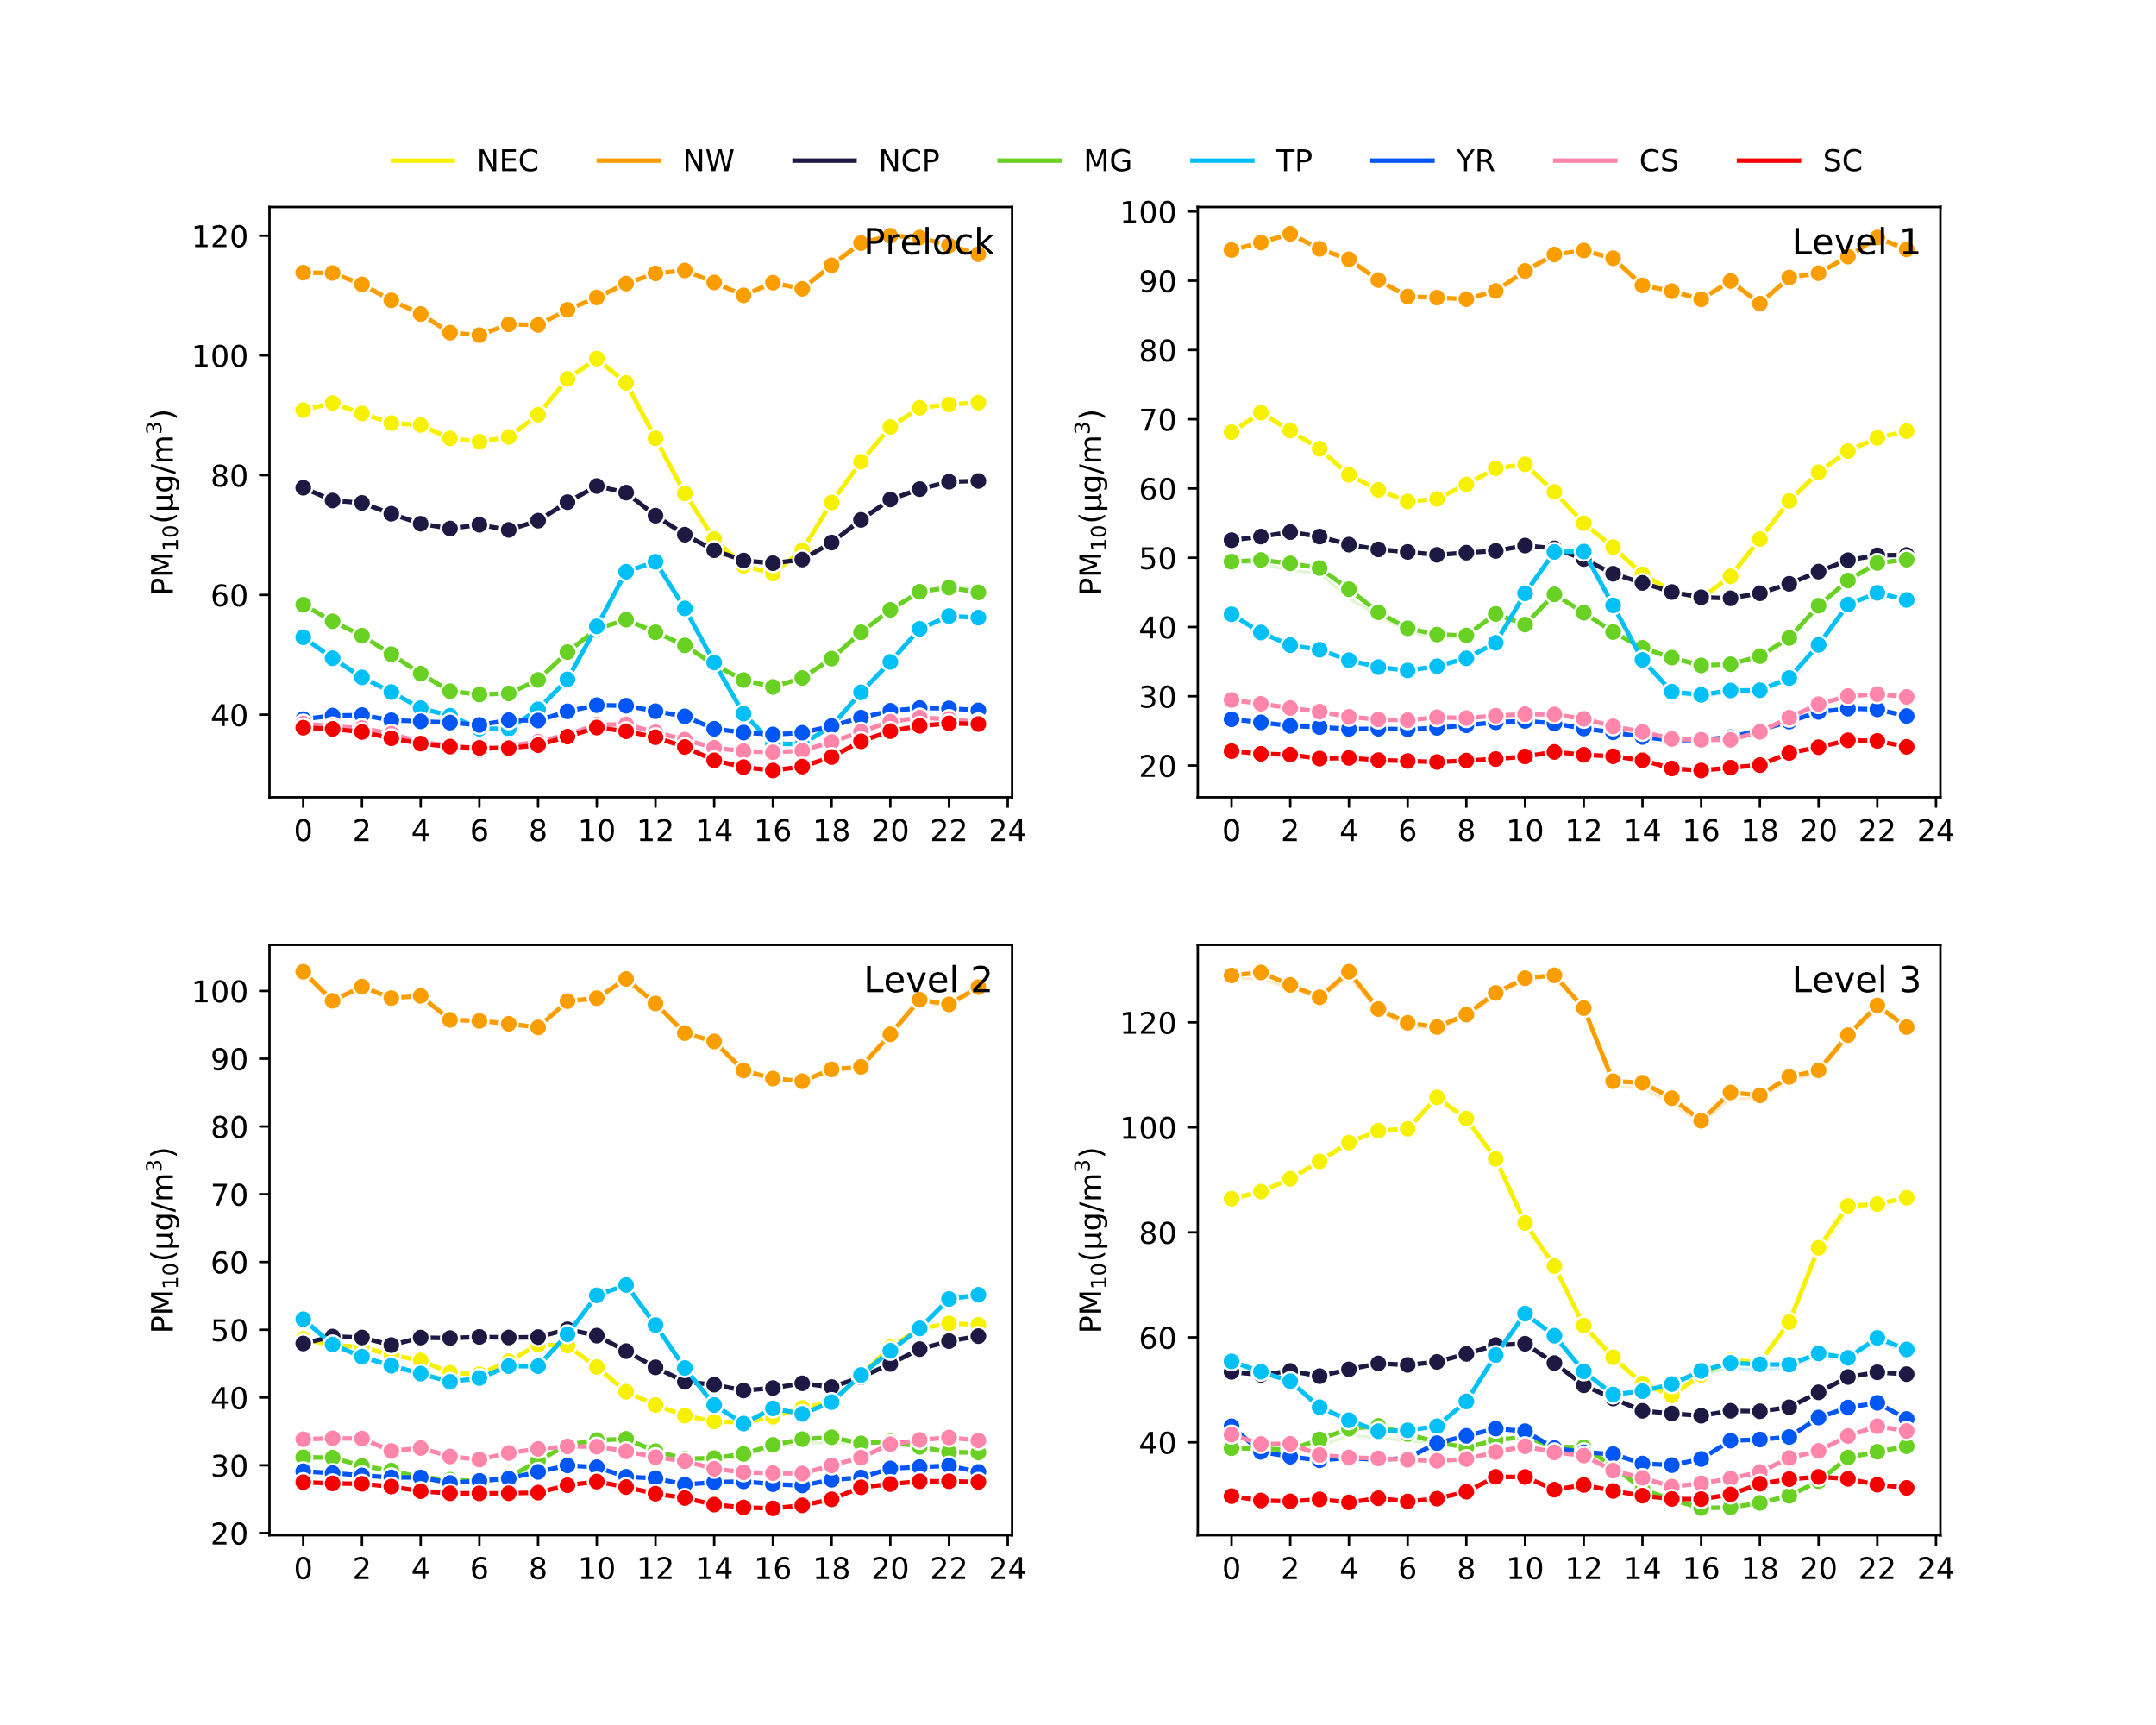

**Fig. S4.** PM10 diurnal variation of four stages.

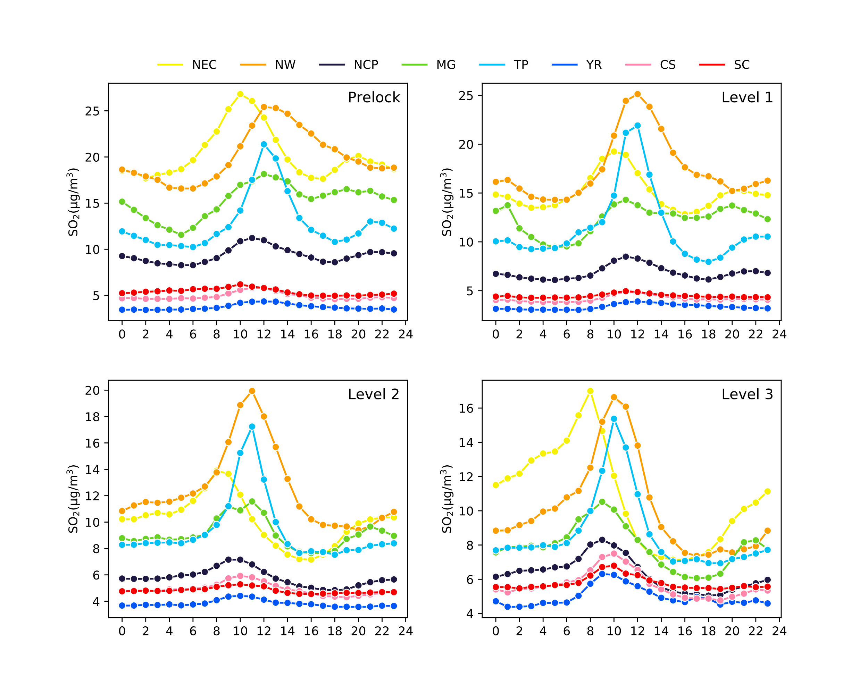

**Fig. S5.** SO2 diurnal variation of four stages.

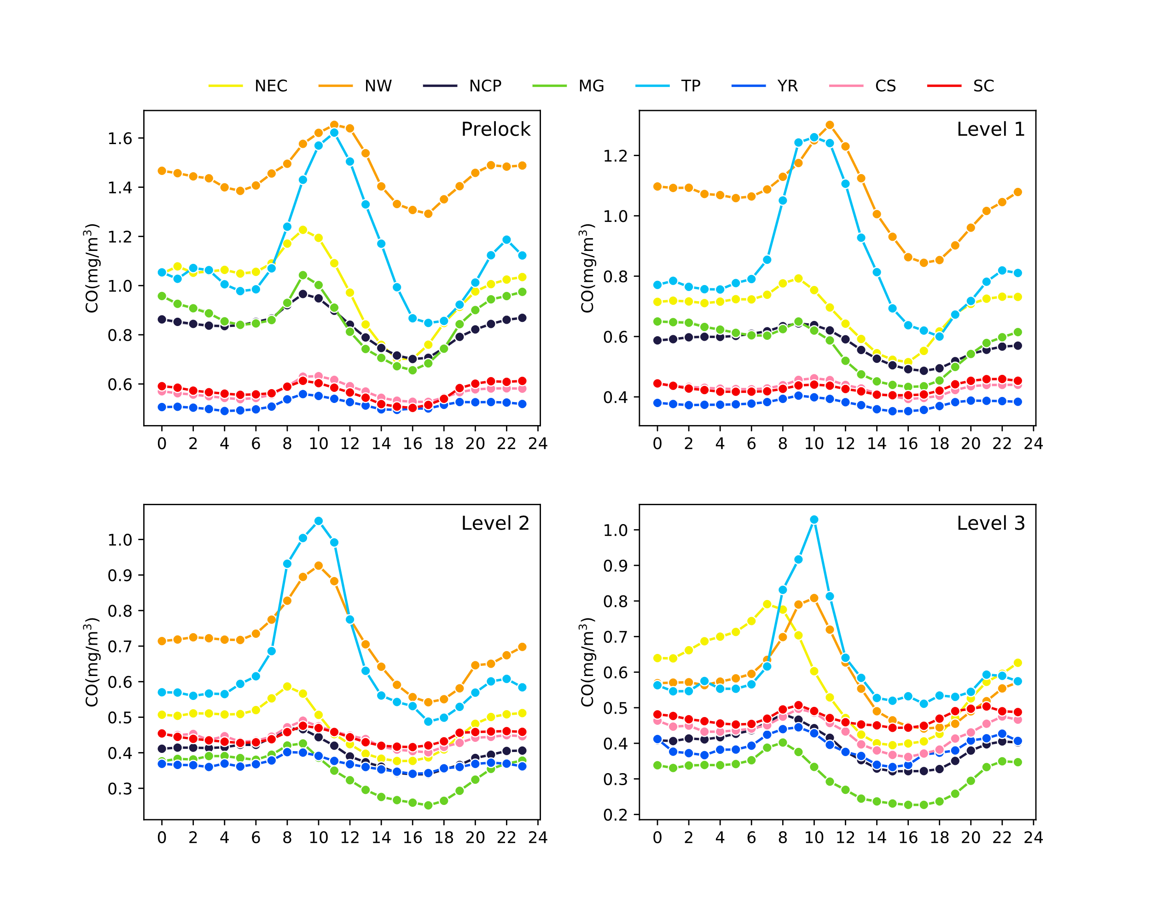

**Fig. S6.** CO diurnal variation of four stages.

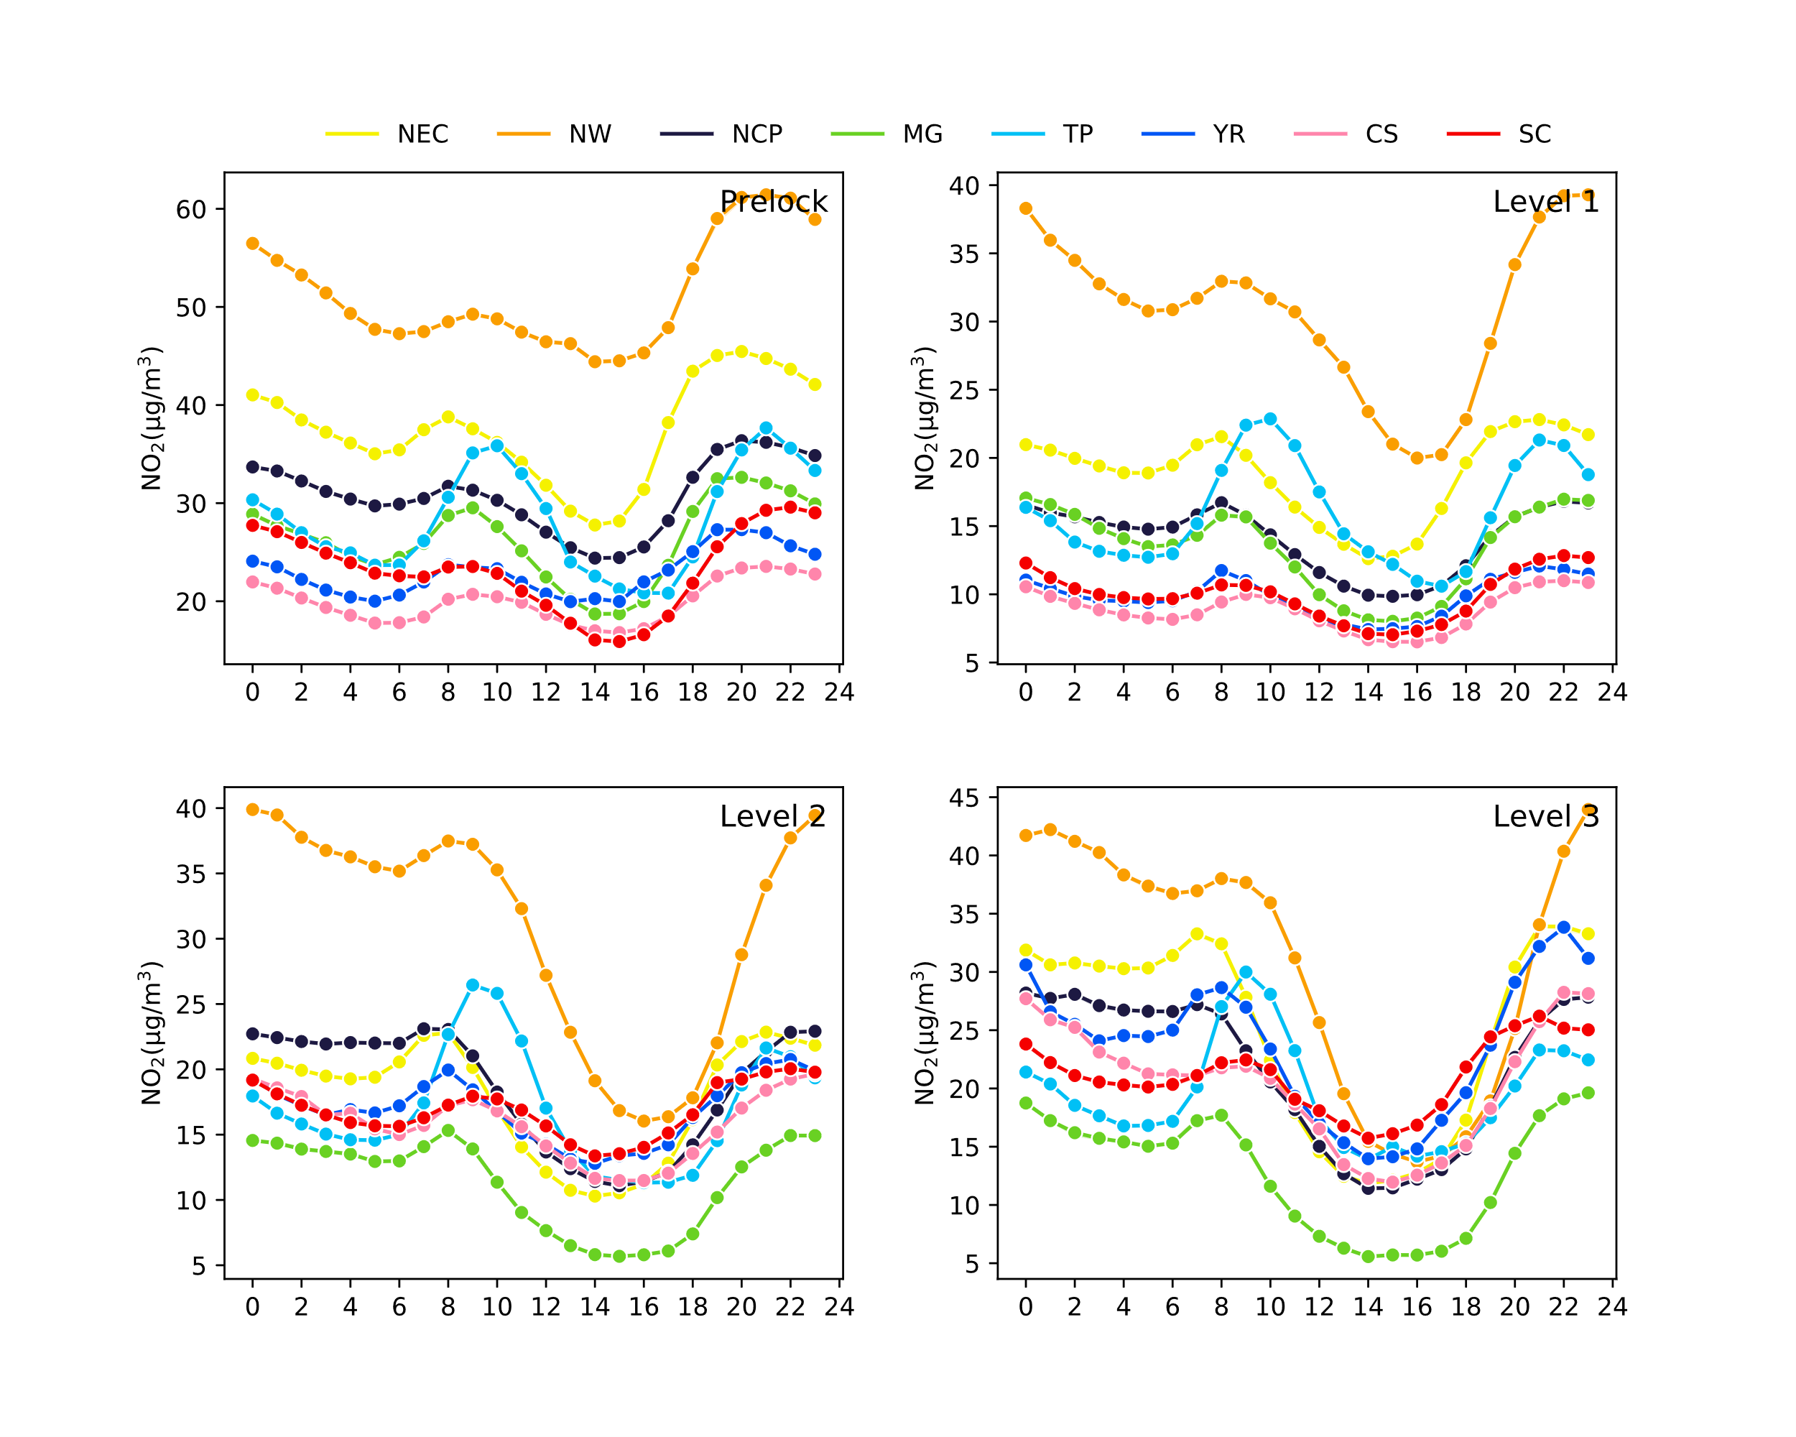

**Fig. S7.** NO2 diurnal variation of four stages.

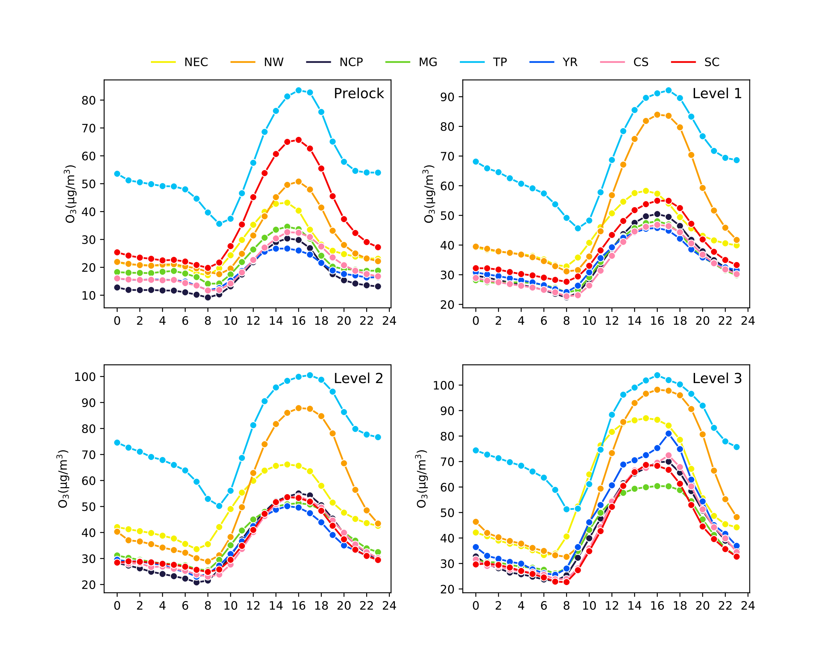

**Fig. S8.** O3 diurnal variation of four stages.

**Table S1. The changed ratio in relative to Pre-lockdown concentration of PM2.5, PM10, SO2, CO, O3, NO2 in three stages (Level 1, 2, 3) during COVID-19 lockdown in china**

|  |  |  |  |  |  |  |  |
| --- | --- | --- | --- | --- | --- | --- | --- |
| **Period** | **Area** | **PM2.5** | **PM10** | **SO2** | **CO** | **O3** | **NO2** |
| Level 1 | NEC | -0.3304 | -0.3136 | -0.2299 | -0.2764 | 0.478 | -0.4911 |
| NW | -0.287 | -0.0177 | -0.0571 | -0.205 | 0.55186 | -0.4404 |
| NCP | -0.3454 | -0.3195 | -0.2818 | -0.3166 | 0.77708 | -0.5323 |
| MG | -0.289 | -0.1915 | -0.2029 | -0.3433 | 0.52813 | -0.4871 |
| TP | -0.2383 | -0.0872 | -0.0943 | -0.1563 | 0.12733 | -0.4122 |
| YR | -0.3438 | -0.3371 | -0.0747 | -0.2151 | 0.6203 | -0.5312 |
| CS | -0.1773 | -0.2128 | -0.1737 | -0.2328 | 0.48428 | -0.5316 |
| SC | -0.1702 | -0.2745 | -0.2317 | -0.2062 | 0.11937 | -0.4915 |
| Level 2 | NEC | -0.5898 | -0.4734 | -0.4688 | -0.4741 | 0.68323 | -0.5461 |
| NW | -0.4321 | 0.21476 | -0.3189 | -0.5225 | 0.62369 | -0.5002 |
| NCP | -0.5831 | -0.3718 | -0.422 | -0.5107 | 0.87403 | -0.3857 |
| MG | -0.6418 | -0.4029 | -0.4091 | -0.598 | 0.6896 | -0.5713 |
| TP | -0.3224 | -0.0327 | -0.1947 | -0.2905 | 0.24661 | -0.3692 |
| YR | -0.4795 | -0.2867 | 0.0308 | -0.2483 | 0.6895 | -0.2547 |
| CS | -0.2609 | -0.1281 | -0.0081 | -0.2573 | 0.63133 | -0.1971 |
| SC | -0.16 | -0.1493 | -0.1107 | -0.1496 | 0.07324 | -0.1898 |
| Level 3 | NEC | -0.1933 | -0.0666 | -0.4356 | -0.3786 | 0.86168 | -0.3492 |
| NW | -0.3626 | 0.48894 | -0.4114 | -0.6151 | 0.79241 | -0.4614 |
| NCP | -0.5979 | -0.3463 | -0.3973 | -0.5258 | 1.15543 | -0.3051 |
| MG | -0.6331 | -0.2957 | -0.4805 | -0.6359 | 0.91634 | -0.5025 |
| TP | -0.207 | 0.21725 | -0.2406 | -0.3379 | 0.25521 | -0.2622 |
| YR | -0.4335 | -0.1598 | 0.20859 | -0.3155 | 0.99042 | -0.034 |
| CS | -0.2458 | -0.0605 | 0.13358 | -0.2914 | 0.99865 | -0.061 |
| SC | -0.0538 | -0.0254 | 0.05225 | -0.1301 | 0.23212 | -0.0314 |

**References**

Hu, J., Wang, Y., Ying, Q., & Zhang, H. (2014). Spatial and temporal variability of PM2.5 and PM10 over the North China Plain and the Yangtze River Delta, China. *Atmospheric Environment*, *95*, 598–609. https://doi.org/10.1016/j.atmosenv.2014.07.019

Sun, Y., Lei, L., Zhou, W., Chen, C., He, Y., Sun, J., … Worsnop, D. R. (2020). A chemical cocktail during the COVID-19 outbreak in Beijing, China: Insights from six-year aerosol particle composition measurements during the Chinese New Year holiday. *Science of The Total Environment*, *742*, 140739. https://doi.org/10.1016/j.scitotenv.2020.140739

Zhang, Y.-L., & Cao, F. (2015). Fine particulate matter (PM 2.5 ) in China at a city level. *Scientific Reports*, *5*(1), 14884. https://doi.org/10.1038/srep14884

Zhao, X., Zhang, X., Xu, X., Xu, J., Meng, W., & Pu, W. (2009). Seasonal and diurnal variations of ambient PM2.5 concentration in urban and rural environments in Beijing. *Atmospheric Environment*, *43*(18), 2893–2900. https://doi.org/10.1016/j.atmosenv.2009.03.009